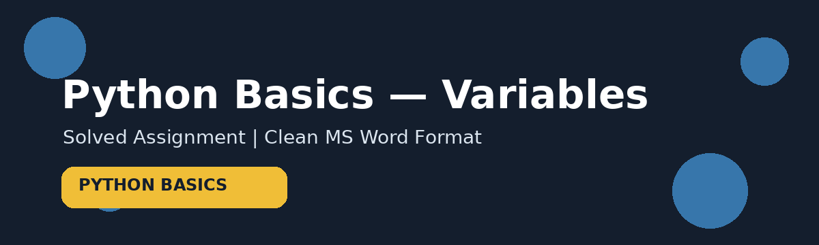
PART - 1
PYTHON BASICS (VARIABLES)
Solved Assignment
Student Name | __Muhammad Musab__________
Subject | __Python____________________

Assignment Overview
This document contains complete solutions for all 7 questions from Part-1 Python Basics (Variables). Each question includes a simple explanation, Python code, expected output, and a visual concept card for a neat and professional submission.

Original Assignment Reference
The uploaded assignment screenshot is included below for reference.
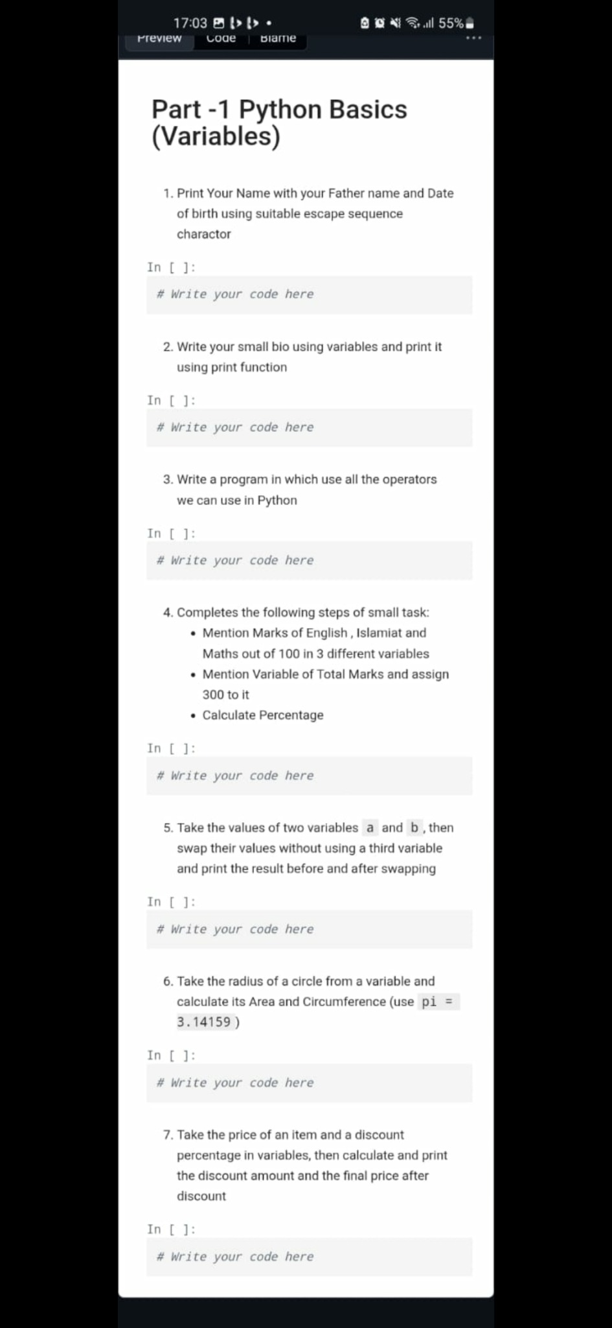

Question 1
Print Your Name with Father Name and Date of Birth using a suitable escape sequence
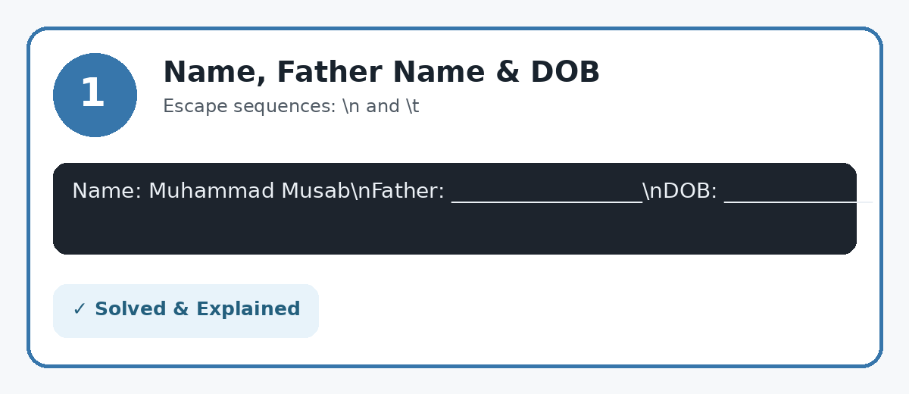
Solution / Python Code
# \n = new line, \t = tab
print("Name:\tMuhammad Musab\nFather Name:\t__________________\nDate of Birth:\t__________________")
Output:
Name: Muhammad Musab
Father Name: __________________
Date of Birth: __________________
Explanation: Escape sequences such as \n and \t make the output organized. Replace the blank fields with the student's actual information.

Question 2
Write a Small Bio using Variables and print it using print()
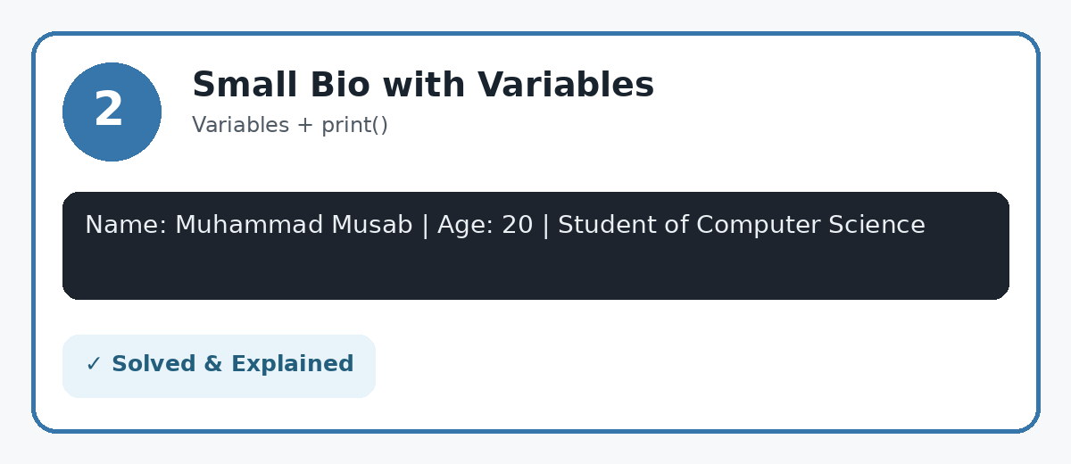
Solution / Python Code
name = "Muhammad Musab"
age = 20
city = "Pakistan"
field = "Computer Science"
print("My name is", name)
print("I am", age, "years old.")
print("I live in", city)
print("I study", field)
Output:
My name is Muhammad Musab
I am 20 years old.
I live in Pakistan
I study Computer Science
Explanation: Variables store information that can be reused. The print() function displays the values.

Question 3
Write a program using all the operators available in basic Python
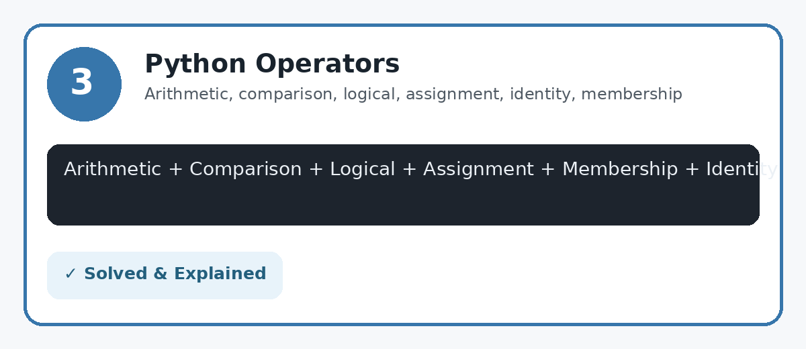
Solution / Python Code
a = 10
b = 3
# Arithmetic
print("Arithmetic:", a+b, a-b, a*b, a/b, a//b, a%b, a**b)
# Comparison
print("Comparison:", a>b, a<b, a==b, a!=b)
# Logical
print("Logical:", (a>b and b>0), (a>b or b<0), not(a<b))
# Assignment
x = 5
x += 2
x *= 3
print("Assignment:", x)
# Membership
print("Membership:", 3 in [1, 2, 3], 7 not in [1, 2, 3])
# Identity
c = [1, 2]
d = c
print("Identity:", c is d, c is not d)
Output:
Arithmetic: 13 7 30 3.3333333333333335 3 1 1000
Comparison: True False False True
Logical: True True True
Assignment: 21
Membership: True True
Identity: True False
Explanation: Python commonly demonstrates arithmetic, comparison, logical, assignment, membership and identity operators. Bitwise operators are also available in Python; the core categories are shown here in one program.

Question 4
Calculate Percentage of English, Islamiat and Maths Marks
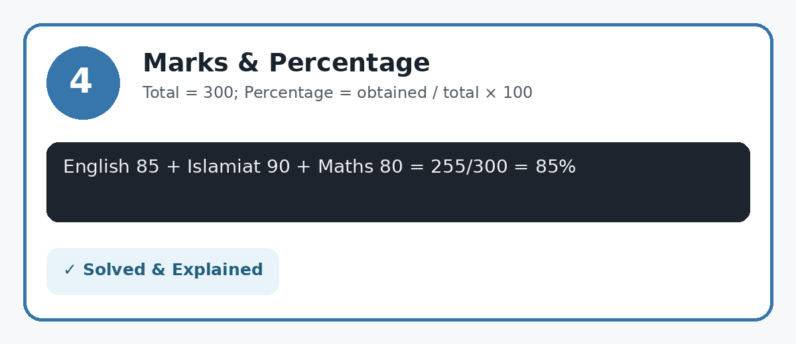
Solution / Python Code
english = 85
islamiat = 90
maths = 80
total_marks = 300
obtained_marks = english + islamiat + maths
percentage = (obtained_marks / total_marks) * 100
print("Obtained Marks:", obtained_marks)
print("Total Marks:", total_marks)
print("Percentage:", percentage, "%")
Output:
Obtained Marks: 255
Total Marks: 300
Percentage: 85.0 %
Explanation: The three subject marks are stored in separate variables. Their sum is divided by the total marks and multiplied by 100.

Question 5
Swap values of a and b without using a third variable
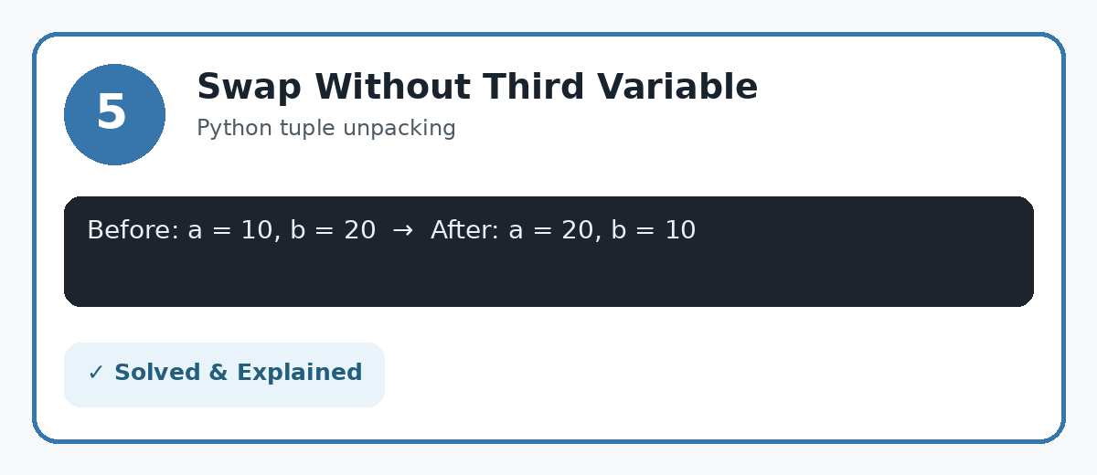
Solution / Python Code
a = 10
b = 20
print("Before swapping: a =", a, "b =", b)
a, b = b, a
print("After swapping: a =", a, "b =", b)
Output:
Before swapping: a = 10 b = 20
After swapping: a = 20 b = 10
Explanation: Python allows multiple assignment, so a and b can be swapped directly without creating a third variable.

Question 6
Calculate Area and Circumference of a Circle
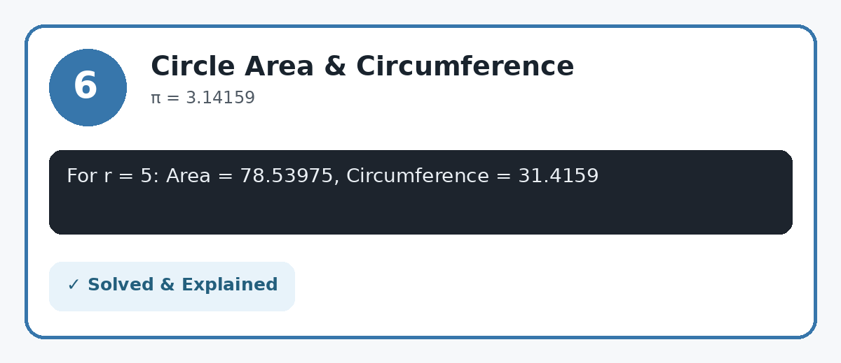
Solution / Python Code
pi = 3.14159
radius = 5
area = pi * radius ** 2
circumference = 2 * pi * radius
print("Radius:", radius)
print("Area:", area)
print("Circumference:", circumference)
Output:
Radius: 5
Area: 78.53975
Circumference: 31.4159
Explanation: Area formula: πr². Circumference formula: 2πr. The question specifically asks to use pi = 3.14159.

Question 7
Calculate Discount Amount and Final Price
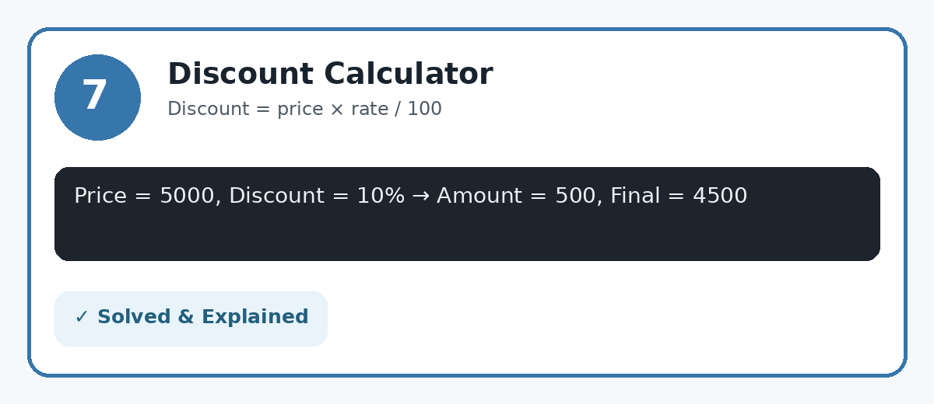
Solution / Python Code
price = 5000
discount_percent = 10
discount_amount = price * discount_percent / 100
final_price = price - discount_amount
print("Original Price:", price)
print("Discount Amount:", discount_amount)
print("Final Price:", final_price)
Output:
Original Price: 5000
Discount Amount: 500.0
Final Price: 4500.0
Explanation: Discount amount is calculated by multiplying price by discount percentage and dividing by 100. The discount is then subtracted from the original price.

Quick Revision — Important Python Concepts
Concept | Example | Purpose
Variable | age = 20 | Stores a value
Print | print(age) | Displays output
New line | \n | Moves output to next line
Tab | \t | Adds tab spacing
Arithmetic | a + b | Performs calculations
Comparison | a > b | Compares values
Logical | a > 5 and b < 10 | Combines conditions
Swap | a, b = b, a | Swaps values
Percentage | obtained/total*100 | Calculates percentage
Discount | price*rate/100 | Calculates discount

✓ Assignment Completed — Ready for Submission

